**Digital Technologies in the Smart Classroom**

Prepared for:

Li wending

Prepared by:

International College Class5

Zhao Yuwei

June 5, 2015

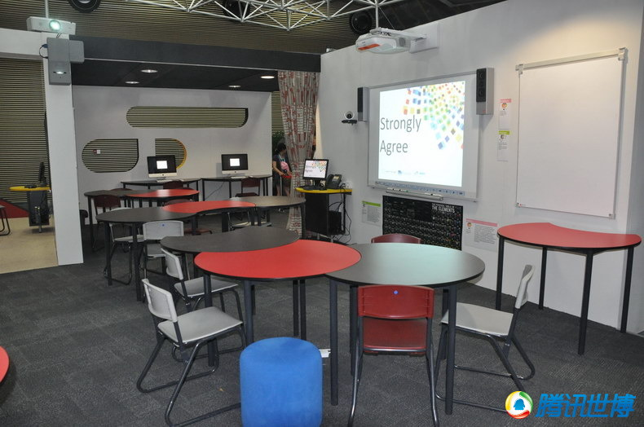

12 Peachtree Street

Atlanta, GA 30056

(404)555-7524

McDuff Project #99-119

June 5, 2015

International college of BUPT

Hong Fu Street

Zhao Yuwei

Attention: Ms. Elaine Skres

**STUDY OF DIGITAL TECHNOLOGIES IN THE SMART CLASSROOM**

I have completed our one week project on the smart classroom research. This project was authorized one June 5, 2015.

This project discussed the development and technologies of the Smart Classroom. This technologies is derived from existing technology integration learning environment instruments, including learning environment and teaching method. This research project aimed to create a constructivist learning environment with digital storytelling.

Thank you for the opportunity to complete this project. I look forward to getting a good grade in this amazing class.

Sincerely,

Zhao Yuwei

**TABLE OF CONTENTS**

PAGE

**LIST OF ILLUSTRATION……………………………………………………………………………………………………………1**

**EXECUTIVE SUMMARY……………………………………………………………………………………………………………2**

**INTRODUCTION……………………………………………………………………………………………………………………..4**

**MAIN METHODOLOGY……………………………………………………………………………………………………………5**

Learning Environment and the Smart Classroom………………………………………………………………5

Digital Storytelling In Smart Classroom……………………………………………………………………………..5

**CONCLUSION…………………………………………………………………………………………………………………………..6**

**INTRODUCTION**

This paper discusses the development and technologies of the Smart Classroom. This technologies is derived from existing technology integration learning environment instruments, including learning environment and teaching method. By learn and research, I focus on storytelling in the classroom. In recent years the use of new technologies in educational systems has increased worldwide as digital cameras, personal computers, scanners, and easy-to-use software have become available to educators to harness the digital world. The impact of new technologies in educational contexts has been mostly positive as new technologies have given educators the opportunity to enhance their knowledge, skills, and therefore enhance the standard of education. Researchers have found that student engagement, achievement and motivation are enhanced through integration of such technologies. However, education systems still face many challenges: one of these challenges is how to enhance student engagement to provide better educational outcomes. It has become increasingly important to use innovative pedagogical models to engage learners. Digital storytelling is one of the innovative pedagogical approaches that can engage students in deep and meaningful learning. This research project aimed to create a constructivist learning environment with digital storytelling.

Now, many classrooms have connected with Internet and equipped with variety advanced information devices, such as tablet PCs and interactive whiteboards. The type of classroom is named as smart classroom, intelligent classroom, or classroom in the future. With the support of technologies, the smart classrooms become the places where teachers and students could practice rich and immersive teaching and learning experiences that they have never had before.

Many researches have explored the relationship between learning skills, learning outcomes and learning environments. Digital storytelling is a good way to structure smart classroom.

**MAIN METHODOLOGY**

**Learning environment and the smart classroom**

The learning environments in schools were described as “a classroom or school climate, environment, atmosphere, tone, ethos, or ambience” (Fraser 1994). The classroom environment is not only a place to house books, desks, and materials, but also a place where teaching and learning activities occur. With a careful design, all the elements in the classroom add a significant dimension to students’ educational experience, supporting and strengthening students’ desire to learn (Loughlin and Suina 1982). Rahman and Mokhtar (2012) found two learning environment elements namely “learning community” and “assessment” had a direct relationship, and three other elements namely “clear objective”, “good teaching” and “learning resources” were indirectly related to generic skills through learning approach. These researches supported the social cognitive theory’s hypothesis that students’ generic skills result from their interaction with their environments.

In the contemporary information society, the low literacy skills such as reading, writing, calculating would be replaced by high literacy such as critical thinking, communication, sharing and complex problem solving. As the result of above researches indicated that the new skills learning not only supported by the innovation on learning contents and learning approaches, but also supported by the learning environments. Based on the data they provided preliminary evidence of the ability of changing students’ approaches to learning through specific changes to the learning environment. So it is necessary to research the classroom environment in the information society; now smart classroom environment has been researched by many countries.

For example, the smart school project in Malaysia, the technology-rich classroom programs in America, and Nanhu primary school’s future classroom project in Taiwan. At the beginning, the term smart classroom is for distinguishing from the term “computer classroom”. It often refers to the classroom equipped with interactive whiteboards to support real-time interaction between teachers and students and carry out teaching and learning activities (Zhao 2008). But now, accompanying with the development of emerging technology, like wireless communication technology, context awareness technology, massive data mining and analysis, and smart interactive technology, smart classroom always represents the technology-rich classroom, i-classroom or future classroom.

Some programs were held to research how the smart classroom should be and what will happen to teaching and learning in the smart classroom. The equipment and appearance of the above classrooms are different, they are all aim to build an open, interactive, flexible and media-rich instruction environment to support the individual or collaborative learning in schools.

**Digital storytelling in smart classroom**

In recent decades, various learning paradigms have been used to enhance teaching and learning practice; each one of these learning theories, such as behaviorism and constructivism, has its own perspective on learning methods. Before explaining the main concepts underpinning each of these theories, first let us consider what a learning theory is. According to Hill, a learning theory is the attempt to explain how people learn, and a paradigm to understand what is fundamentally involved in the learning process (Hill 2002).Behavior patterns include the use of direction signs and learning practice. Constructivism is one of the most influential educational approaches developed in recent times. It overlaps the cognitive learning school in many ways; however, it is characterised by its emphasis on learning through the use of authentic contexts, and a focus on the importance of the social dimension of learning. Wilson defines it as “a place where learners may work together and support each other as they use a variety of tools and information resources in their guided pursuit of learning goals and problem solving activities” (Wilson 1996).

In addition, according to Anderson the constructivist has more than a simple perspective on learning, recognizing that people explain the learnt information and the world around them, based on their personal vision (Anderson 2008). To sum up, the most important learning characteristics of constructivism are that learners can build on their own interpretation of the world, depending on experience and interaction, and that will generate a new understanding through the collection of knowledge from various sources (Duffy et al. 2012).

On the other hand, the education theories developed in the 20th century consider teaching and learning as more than mere interaction or transmission of knowledge. These theories consider teaching as a specific paradigm of teacher–student interaction, where the desired role of the adult is a collaborator and/or co-constructor.

Bouman defines learning as the acquisition of knowledge or skills through experience, practice, or study, or by being taught. He classifies learning under different headings: the two main ones are student-led and teacher-led learning. Student-led learning is a process of learning information where students ask questions of one another, while they assist each other as peers in discussing the method used to acquire the answers to those questions; students are also allowed to work with one another in a studentcentred environment. Teacher-led learning is currently the most popular form of teaching students. This method involves the teacher holding all the information and sharing it with the students over time. Digital storytelling can thus facilitate a constructivist approach for teaching and learning. It can be a helpful educational tool, as it provides a vehicle for combining digital media with innovative teaching and learning practices. Consequently, as the literature review has revealed, digital storytelling is a powerful model for creating constructivist e-Learning environments. Digital storytelling has the potential to engage learners in integrated approaches to learning with digital media.

Furthermore, digital storytelling enhances learners’ motivation, and helps teachers in building constructivist learning environments. To facilitate the harnessing of these pedagogical benefits we need an overarching framework for creating digital stories.

This framework should be cognisant of the needs and capabilities of learners at their various stages of learning (i.e. catering for learners from primary school to university level, and even professional e-Learning content creators).

This research presented a new e-Learning Digital Storytelling framework to be able to use digital storytelling as a pedagogical model for constructivist learning. This framework was developed for application of digital storytelling at various stages of learning. The e-Learning Digital Storytelling framework also articulates how storytelling can be used at different levels of

education.

Therefore, the mission of this research is to create a methodology for building constructivist learning environments based on digital storytelling, the outcomes of this research project aim to help teachers and learners tap into the power of digital storytelling and partake in more engaged teaching and learning.

**CONCLUSION**

Individual case studies using mixed methods constitute the body of this research. Data for this study was collected through observations, the evaluation rubric. Four separate case reports were prepared. The case reports aim to answer the research questions.